**ANNEX 5: PRODUCT REQUIREMENTS DOCUMENT**

**Applicant Organisation Name:**

**PART 1:**

1. **Describe the primary use case(s) (real-world application) for your solution.** Include here both actual and potential use cases of your solution. Please provide data/results of any pilots. For each actual and potential use case, provide an explanation for why you feel the technology is suitable for this use case.

|  |  |  |  |
| --- | --- | --- | --- |
|  | **Use case 1** | **Use case 2** | **Use case 3** |
| Brief Description  (Max. 200 words each) | Monitoring and Controlling phone calls, SMS, Social Media, images, videos, websites, live Chat, live streaming | Blocking any un proper content (videos, images, live chat, live streaming… etc.) or any content set by the admin | Reports on the blocked contacts, websites, video sources, ... etc. to be sent to competent authorities |
| Actual or Potential | Actual | Actual | Potential |
| If available, summarise pilot results that confirm the use case and provide links to data and results  (Max. 200 words) | There is a Prototype will describe the steps and results |  |  |
| Why technology is suitable for this use case (Max. 200 words) | As all un proper content now presented to the children throw internet and applications with its different types, so we will fight them using technology also |  |  |

1. **What are the components within your solution that you will develop / refine / test over the duration of the investments (max 24 months)?** *Please make sure these milestones are linked to the Project Milestones and Implementation Plan in Annex 3.*

|  |  |  |  |  |
| --- | --- | --- | --- | --- |
| **Milestone (align with Annex 3)** | **Quarter** | **Component details** | **Status (e.g. developing, refining)** | **Result (e.g. parts developed, feature-tested and bugs fixed, level of accuracy, etc…)** |
|  | Quarter 1 | * Administration Web Application * Web application dashboard for Monitor | Development and implementation | Tested and published |
|  | Quarter 2 | Android and IOS Mobile Application for Monitor (Parent) | Development and Implementation | Tested and published |
|  | Quarter 3 | Android and IOS Mobile application for User (Child) | Development and implementation | Tested and published |
|  | Quarter 4 | Child Security Web Application | Development and implementation | Tested and Published |
|  | Quarter 5 |  |  |  |
|  | Quarter 6 |  |  |  |
|  | Quarter 7 |  |  |  |
|  | Quarter 8 |  |  |  |

**PART 2:**

**Please choose the most relevant technology category(ies) for your solution and complete questions on either**

**A) Software;**

**B) Hardware and/or**

**C) Content**

*Make sure all relevant components are covered. You can provide answers in one, two or three categories.

**SECTION A: SOFTWARE**

1. **Prototyping: Describe the work you have done on proofs of concept, mockups, and user testing.** List the last three versions of your solution’s design. For each version, please provide 2 sentences that describe the reasons for the changes (including data) and outline the main changes made.

|  |  |  |  |
| --- | --- | --- | --- |
| **Version** | **Main characteristics and features** | **Main changes from previous version** | **Reasons for changes made**  (incl data collected/ feedback received/ refined understanding of user needs): |
| Version 1 |  |  |  |
| Version 2 |  |  |  |
| Version 3 |  |  |  |

1. **Before you developed your own, or selected an existing one, what other similar technologies did you consider using, improving or iterating to solve the problem you want to solve?** Outline what other technologies were considered to address the problem you identified and why were they rejected as unsuitable.

|  |  |  |
| --- | --- | --- |
|  | **Technology description** (200 characters limit) | **Unsuitable because:** (500 characters limit) |
| 1 |  |  |
| 2 |  |  |
| 3 |  |  |
| 4 |  |  |

1. Please select the license type that your solutions are currently registered under.

AGPL

LGPL

BSD

Other equivalent (please specify):

Not currently on an open source license

1. **If currently not on an open source license, are you willing to release your tech solution under an AGPL, LGPL, BSD or equivalent open-source license** (Please note that the Fund encourages and will give preference to solutions that are open source. It also aspires to have any tools that it invests in be available to the widest range of actors possible and free of charge or at a very low cost):

Yes

No

1. **Please insert at the end of this template (Annex 1) a diagram of your current tech stack including all components and subsystems, showing their linkages and interactions. A tech stack is a combination of software products and programming languages used. For this diagram, include: both client side and server side documentation if relevant, tools used for front-end and back-end systems (including databases), and any meta-layers**. **If you are using machine learning, please describe your pipeline.**

**Please find here two examples of tech stacks that you can use as templates:**

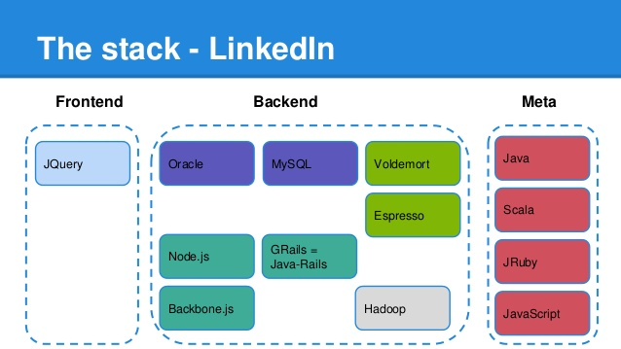

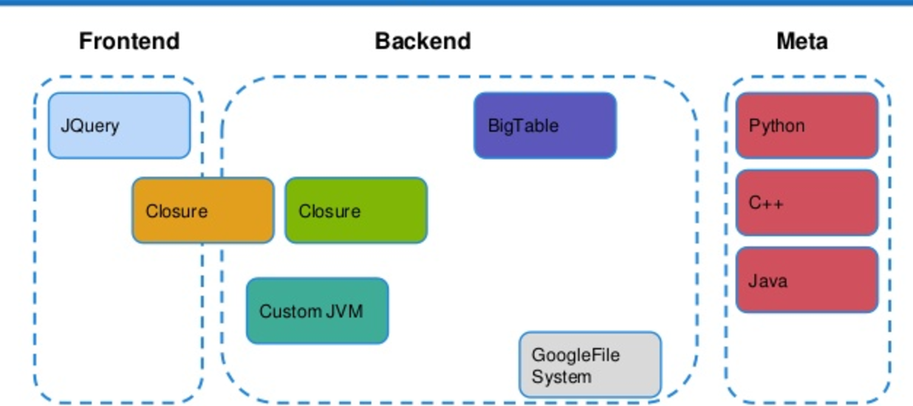

1. **In addition, please provide written documentation explaining the diagram provided, outlining each element included in the diagram, its role and its status of development (complete, under development, expected date of completion etc). Please clarify if these components are currently open source or proprietary, and in the case of the latter if you intend to put them on an open source license. Include links or documents outlining process documentation, system documentation, user documentation, and any instructions on API usages, if relevant.** (5,000 characters limit)

1. **Where do you host the repositories of your solution?** *Please note that the Fund may request further information about and/or access to the repositories for this solution***:**
   1. **GitHub**
   2. **Bitbucket**
   3. **Other** (please specify)**:**
2. **Sustainability: What is the ongoing plan for maintenance, updates, and support of your software?** Describe what the needs will be for the next two years and how these will be met.(1,000 characters limit)

1. **If your organisation is using data as a central part of the solution:**
   1. **Describe your data sets (i.e. size, features, method of collection, labels). If applies, please also include the description of the test and training data sets.** (1,000 characters limit)

* 1. **Describe how you already collect or plan to collect data and with which technologies.** (1,000 characters limit)

* 1. **Describe who is the owner of the data and what licenses is it under.** (1,000 characters limit)

* 1. **If you use personally identifiable indicators, please describe how you secure the privacy of individuals.** (1,000 characters limit)

1. **If your organisation is using machine learning or A.I:**
   1. **Describe your models and why you settled on using them. (E.g. we use Logistic Regression because it is easy to interpret, and we don't have enough data to use more sophisticated methods).** (1,000 characters limit)

* 1. **How do you evaluate your models / methods? (i.e. accuracy, F1 score, Regression coefficient)** (1,000 characters limit)

* 1. **Describe your roadmap to further improving your model and how you plan to maintain it and keep it up-to-date** (1,000 characters limit)

* 1. **Describe the limitations of your methodology: Where does your approach fail? (e.g. your predictions are biased because you do not have enough data for a certain class)** (1,000 characters limit)

1. **If your organisation is using blockchain:**
   1. **What blockchain platform are you using? (ie. Bitcoin, Ethereum, Hyperledger, etc). Please explain your choice and clarify whether it is a private or public chain.** (1,000 characters limit)

* 1. **Is your product deployed? If so, where? (ie. private node, mainnet, test net)** (1,000 characters limit)

* 1. **What consensus algorithm does the blockchain you’re using use? (ie. Proof of Work, Proof of Stake, Delegated Proof of Stake)** (1,000 characters limit)

* 1. **What language are you using to create your smart contracts? (ie. Solidity, Lvy, Viper).**  (1,000 characters limit)

* 1. **How do you go about testing your smart contracts?** (1,000 characters limit)

* 1. **Is personal/biometric data being stored in the blockchain? If yes, how are you ensuring the privacy of that data?** (1,000 characters limit)

**SECTION B: HARDWARE (leave blank, if no hardware-related components to your project)**

1. **Please select the license type that your solution is registered under.**

CERN

Other equivalent:

Not currently on an open source license

1. **If currently not on an open source license, are you willing to release your tech solution under a CERN or equivalent open-source license.** *Please note that the Fund encourages and will give preference to solutions that are open source. It also aspires to have any tools that it invests in be available to the widest range of actors possible and free of charge or at a very low cost.*

Yes

No

1. **In the space provided at the end of this template (Annex 2), provide a detailed diagram of the hardware you are developing.** Include block diagrams of overall system architecture, hardware schematics, images of your system, and detailed drawings and descriptions (this can include CAD or 3D diagrams, electronics layouts, rough BOM, and links to relevant documentation).
2. **In addition, please provide written documentation explaining the diagram provided, outlining each element included in the diagram, its role and its status of development (complete, under development, expected date of completion etc). Please clarify if these components are currently open source or proprietary, and in the case of the latter if you intend to put them on an open source license. Include links or documents outlining process documentation, system documentation, user documentation.** (5,000 characters limit)

1. **Please provide a component list with supplier/ SKU numbers and origin (where do you source each component from).** Be sure to list every component displayed in the exploded view in Annex 2.

1. **How many units of your product are currently available?**

1. **a) How much does** **each unit cost to produce?**

**b) How does the cost change as the number of units increase?**

1. **Where do you manufacture your product?**

**SECTION C: CONTENT**

1. **Please provide an overview of the new content you have created or are planning to create.** Provide a description that includes but is not limited to: subject, audience, language, format, medium. (1,000 characters limit)

1. **Who else is developing similar or identical content? How is your new content different from the existing one? What is the gap you are attempting to address?** (1,000 characters limit)

1. **List the learning objectives you are planning to meet through the content**. (1,000 characters limit)

1. **Please insert on the last page of this template (Annex 3), a content/curriculum map diagram (max 1 page), including the general organization of the content, rough relational hierarchy.** **Please clarify if any these components are currently open source or proprietary, and in the case of the latter if you intend to put them on an open source license.** Be sure to give details at the lowest level of granularity of your content.
2. **Please provide a sample of the content you have created (at the end of this template Annex 4) and/or plan to create (copy/paste at the end of this form in the appropriate place).** The sample should cover one piece, ie one video, one pdf, one set of exercises etc.
3. **Provide a short explanation that shows how this sample relates to the overall content.** Describe the context of the example content within your larger set of content. (1,000 characters limit)

1. **Please describe how the content will be delivered to the user (face-to-face facilitation, self-paced, etc).** (1,000 characters limit)

1. **Please explain where the content will be hosted and how the user will access the content** (LMS, CMS, etc.). (1,000 characters limit)

1. **Provide the number of content objects (including the breakdown of media types)…**

a) ...currently offer:

-audio (e.g. mp3)

-video (e.g. mp4)

-rich text (pdf, html, other markup language)

-pure HTML5 frontend apps (embeddable in iframe)

b) propose to create:

-audio (e.g. mp3)

-video (e.g. mp4)

-rich text (pdf, html, other markup language)

-pure HTML5 frontend apps (embeddable in iframe)

1. **Please select the license type that your solution is registered under.**

CC-BY

CC-BY-SA

CC-BY-NC

CC-BY-ND

CC-BY-NC-SA

CC-BY-NC-ND

Other equivalent (please specify):

Not currently on an open source license

1. **If currently not on an open source license, are you willing to release your tech solution under a CC-BY or CC-BY-SA or equivalent open-source license** (please refer to the Funding Agreement to consider the obligations for open sourcelicensing and investment by the Innovation Fund):

Yes

No

1. **Sustainability:** How will content be adapted and/or updated based on user needs, feedback and data collected? (1,000 characters limit)

**ANNEX 1: SECTION A. QUESTION 5**

***PLEASE INSERT HERE: Annex 1:* a diagram of your current tech stack including all components and subsystems, showing their linkages and interactions. A tech stack is a combination of software products and programming languages used. For this diagram, include: both client side and server side documentation if relevant, tools used for front-end and back-end systems (including databases), and any meta-layers**.

**ANNEX 2: Section B, Question 3**

***PLEASE INSERT HERE: Annex 2:* detailed diagram of the hardware you are developing.** Include block diagrams of overall system architecture, hardware schematics, images of your system, and detailed drawings and descriptions (this can include CAD or 3D diagrams, electronics layouts, rough BOM, and links to relevant documentation).

**ANNEX 3: SECTION C. QUESTION 4**

***PLEASE INSERT HERE: Annex 3:* a content/curriculum map diagram (max 1 page), including the general organization of the content, rough relational hierarchy.** Be sure to give details at the lowest level of granularity of your content.

**ANNEX 4: SECTION C. QUESTION 5**

***PLEASE INSERT HERE: Annex 4:* a sample of the content you have created (at the end of this template Annex 4) and/or plan to create (copy/paste at the end of this form in the appropriate place).** The sample should cover one piece, i.e. one video, one pdf, one set of exercises etc.